1-ROLLBACK

🔁 What is ROLLBACK?
# Source: AI Source: Provided by: [Data Path: Persons Table -> ID Column: 1, Name_En Column: Motasem Essam] -> From: [ChatGPT] on [6/11/2026]
ROLLBACK is a TCL (Transaction Control Language) command used to undo changes made in the current transaction before a COMMIT is issued.

✅ Syntax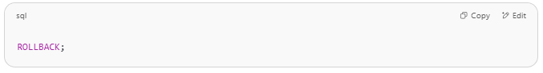
ROLLBACK;

📌 When to Use ROLLBACK
# Source: AI Source: Provided by: [Data Path: Persons Table -> ID Column: 1, Name_En Column: Motasem Essam] -> From: [ChatGPT] on [6/11/2026]
- If an error occurs during a transaction.
- If you realize something went wrong and want to undo the changes.
- If you want to return to a previous savepoint (advanced usage).

🧪 Example Scenario

Step 1: Disable autocommit (MySQL default is ON)
# Source: AI Source: Provided by: [Data Path: Persons Table -> ID Column: 1, Name_En Column: Motasem Essam] -> From: [ChatGPT] on [6/11/2026]
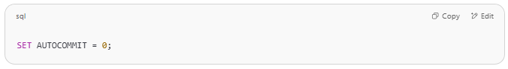
SET AUTOCOMMIT = 0;

Step 2: Start transaction
# Source: AI Source: Provided by: [Data Path: Persons Table -> ID Column: 1, Name_En Column: Motasem Essam] -> From: [ChatGPT] on [6/11/2026]
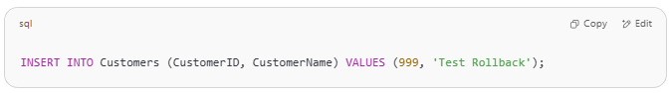
INSERT INTO Customers (CustomerID, CustomerName) VALUES (999, 'Test Rollback');

Step 3: Rollback changes
# Source: AI Source: Provided by: [Data Path: Persons Table -> ID Column: 1, Name_En Column: Motasem Essam] -> From: [ChatGPT] on [6/11/2026]
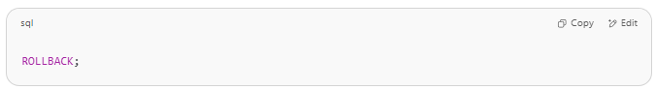
ROLLBACK;

Step 4: Check results
# Source: AI Source: Provided by: [Data Path: Persons Table -> ID Column: 1, Name_En Column: Motasem Essam] -> From: [ChatGPT] on [6/11/2026]
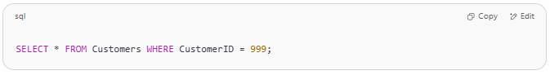
SELECT * FROM Customers WHERE CustomerID = 999;

🟥 The row will not exist, because the insert was rolled back.

🧩 With SAVEPOINT (Optional Advanced Usage)
# Source: AI Source: Provided by: [Data Path: Persons Table -> ID Column: 1, Name_En Column: Motasem Essam] -> From: [ChatGPT] on [6/11/2026]
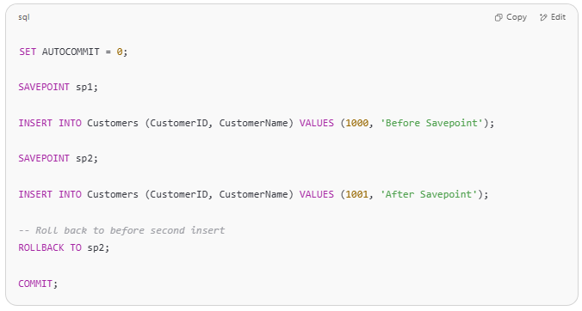
SET AUTOCOMMIT = 0;

SAVEPOINT sp1;

INSERT INTO Customers (CustomerID, CustomerName) VALUES (1000, 'Before Savepoint');

SAVEPOINT sp2;

INSERT INTO Customers (CustomerID, CustomerName) VALUES (1001, 'After Savepoint');

-- Roll back to before second insert
ROLLBACK TO sp2;

COMMIT;

✅ Result: Only CustomerID 1000 is committed.

⚠️ Important Notes
# Source: AI Source: Provided by: [Data Path: Persons Table -> ID Column: 1, Name_En Column: Motasem Essam] -> From: [ChatGPT] on [6/11/2026]
- ROLLBACK only works on uncommitted changes.
- Once a COMMIT is executed, rollback has no effect on that transaction.
- Transactions must be explicitly started by disabling autocommit (SET AUTOCOMMIT = 0).

When ROLLBACK is will work
# Source: AI Source: Provided by: [Data Path: Persons Table -> ID Column: 1, Name_En Column: Motasem Essam] -> From: [ChatGPT] on [6/11/2026]
is ROLLBACK work if there are problem or any way is will work
Great question! Let’s clarify how ROLLBACK works in MySQL, especially in transactional contexts.

✅ What is ROLLBACK?
# Source: AI Source: Provided by: [Data Path: Persons Table -> ID Column: 1, Name_En Column: Motasem Essam] -> From: [ChatGPT] on [6/11/2026]
ROLLBACK is used to undo all or part of a transaction in MySQL, depending on how you use it.
- ROLLBACK (without a savepoint) undoes all uncommitted changes in the current transaction.
- ROLLBACK TO SAVEPOINT name undoes everything after that savepoint, but keeps changes before it.

🔒 Requirements for ROLLBACK to Work

✅ 1. You must be inside a transaction
# Source: AI Source: Provided by: [Data Path: Persons Table -> ID Column: 1, Name_En Column: Motasem Essam] -> From: [ChatGPT] on [6/11/2026]
MySQL will only allow rollbacks if you have turned off autocommit:
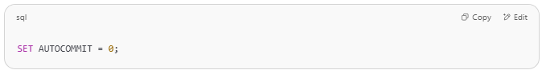
SET AUTOCOMMIT = 0;

or started an explicit transaction:
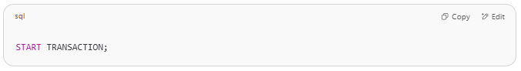
START TRANSACTION;

If you're not in a transaction, then changes are auto-committed and ROLLBACK won’t do anything.

✅ 2. Your table must use the InnoDB storage engine
# Source: AI Source: Provided by: [Data Path: Persons Table -> ID Column: 1, Name_En Column: Motasem Essam] -> From: [ChatGPT] on [6/11/2026]
- MyISAM tables do not support transactions.
- Only InnoDB supports ROLLBACK, SAVEPOINT, and COMMIT.
Check your table with:
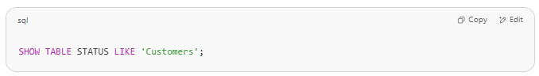
SHOW TABLE STATUS LIKE 'Customers';

Look for the Engine column. It must say InnoDB.

❗ Situations Where ROLLBACK Won’t Work
# Source: AI Source: Provided by: [Data Path: Persons Table -> ID Column: 1, Name_En Column: Motasem Essam] -> From: [ChatGPT] on [6/11/2026]
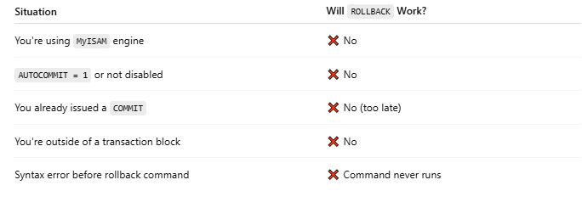
Situation | Will ROLLBACK Work?
You're using MyISAM engine | ❌ No
AUTOCOMMIT = 1 or not disabled | ❌ No
You already issued a COMMIT | ❌ No (too late)
You're outside of a transaction block | ❌ No
Syntax error before rollback command | ❌ Command never runs

✅ When Will ROLLBACK Work?
# Source: AI Source: Provided by: [Data Path: Persons Table -> ID Column: 1, Name_En Column: Motasem Essam] -> From: [ChatGPT] on [6/11/2026]
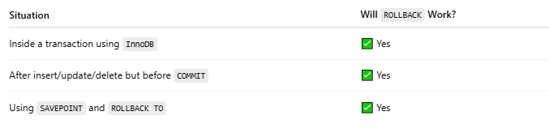
Situation | Will ROLLBACK Work?
Inside a transaction using InnoDB | ✅ Yes
After insert/update/delete but before COMMIT | ✅ Yes
Using SAVEPOINT and ROLLBACK TO | ✅ Yes

🔁 Example
# Source: AI Source: Provided by: [Data Path: Persons Table -> ID Column: 1, Name_En Column: Motasem Essam] -> From: [ChatGPT] on [6/11/2026]
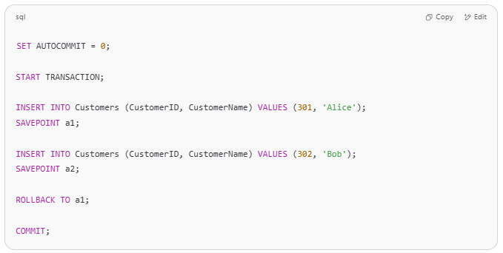
SET AUTOCOMMIT = 0;

START TRANSACTION;

INSERT INTO Customers (CustomerID, CustomerName) VALUES (301, 'Alice');
SAVEPOINT a1;

INSERT INTO Customers (CustomerID, CustomerName) VALUES (302, 'Bob');
SAVEPOINT a2;

ROLLBACK TO a1;

COMMIT;

✅ Only Alice remains.

Would you like a simple diagnostic query to check if your table supports rollback?

🧠 Summary
# Source: AI Source: Provided by: [Data Path: Persons Table -> ID Column: 1, Name_En Column: Motasem Essam] -> From: [ChatGPT] on [6/11/2026]
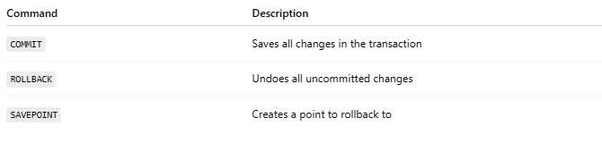

Command | Description
COMMIT | Saves all changes in the transaction
ROLLBACK | Undoes all uncommitted changes
SAVEPOINT | Creates a point to rollback to

how check i use MyISAM or InnoDB
# Source: AI Source: Provided by: [Data Path: Persons Table -> ID Column: 1, Name_En Column: Motasem Essam] -> From: [ChatGPT] on [6/11/2026]
You can check whether a table uses MyISAM or InnoDB (or another storage engine) by running one of the following commands in MySQL or phpMyAdmin.

✅ Method 1: Use SHOW TABLE STATUS
# Source: AI Source: Provided by: [Data Path: Persons Table -> ID Column: 1, Name_En Column: Motasem Essam] -> From: [ChatGPT] on [6/11/2026]
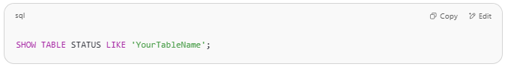
SHOW TABLE STATUS LIKE 'YourTableName';

🔍 Example:
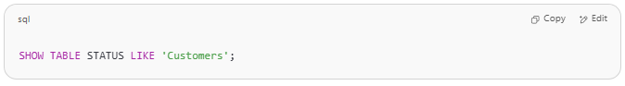
SHOW TABLE STATUS LIKE 'Customers';

📌 This returns a row of metadata about the table. Look at the Engine column:
Name | Engine
Customers | InnoDB
If it says InnoDB → ✅ supports transactions (COMMIT, ROLLBACK, SAVEPOINT)
If it says MyISAM → ❌ no transaction support

✅ Method 2: Use INFORMATION_SCHEMA
# Source: AI Source: Provided by: [Data Path: Persons Table -> ID Column: 1, Name_En Column: Motasem Essam] -> From: [ChatGPT] on [6/11/2026]
You can also use this query:
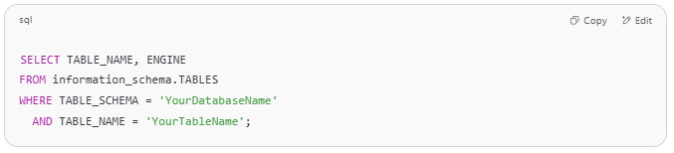
SELECT TABLE_NAME, ENGINE
FROM information_schema.TABLES
WHERE TABLE_SCHEMA = 'YourDatabaseName'
AND TABLE_NAME = 'YourTableName';

📌 Replace:
- 'YourDatabaseName' with the actual name of your database
- 'YourTableName' with the name of your table

✅ How to Change Engine (Optional)
# Source: AI Source: Provided by: [Data Path: Persons Table -> ID Column: 1, Name_En Column: Motasem Essam] -> From: [ChatGPT] on [6/11/2026]
If your table is MyISAM and you want to convert it to InnoDB:
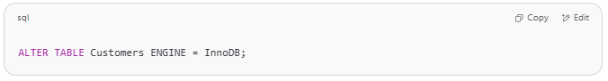
ALTER TABLE Customers ENGINE = InnoDB;

⚠️ Be sure to back up your data before doing this in production.

SAVEPOINT

🎯 What is SAVEPOINT?
# Source: AI Source: Provided by: [Data Path: Persons Table -> ID Column: 1, Name_En Column: Motasem Essam] -> From: [ChatGPT] on [6/11/2026]
SAVEPOINT is a TCL command used to set a point within a transaction that you can later ROLLBACK to, without rolling back the entire transaction.
This allows partial undo of changes within a transaction.

✅ Syntax
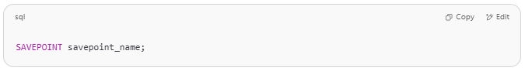
SAVEPOINT savepoint_name;

To roll back to it:
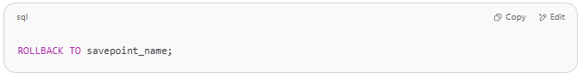
ROLLBACK TO savepoint_name;

To release it:
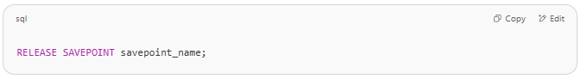
RELEASE SAVEPOINT savepoint_name;

🧪 Example Use Case
# Source: AI Source: Provided by: [Data Path: Persons Table -> ID Column: 1, Name_En Column: Motasem Essam] -> From: [ChatGPT] on [6/11/2026]
Suppose you’re transferring money between two accounts and want to cancel only the second step:
Step-by-step in MySQL:
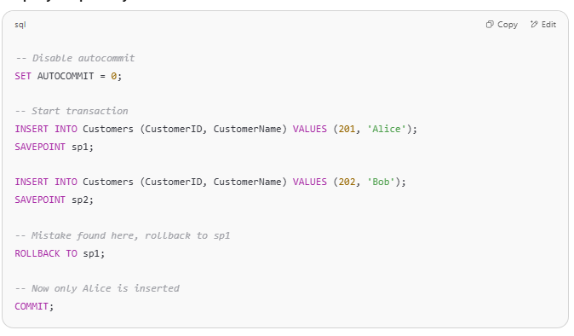
-- Disable autocommit
SET AUTOCOMMIT = 0;

-- Start transaction
INSERT INTO Customers (CustomerID, CustomerName) VALUES (201, 'Alice');
SAVEPOINT sp1;

INSERT INTO Customers (CustomerID, CustomerName) VALUES (202, 'Bob');
SAVEPOINT sp2;

-- Mistake found here, rollback to sp1
ROLLBACK TO sp1;

-- Now only Alice is inserted
COMMIT;

🧾 Explanation:
# Source: AI Source: Provided by: [Data Path: Persons Table -> ID Column: 1, Name_En Column: Motasem Essam] -> From: [ChatGPT] on [6/11/2026]
- sp1 created after inserting Alice.
- sp2 created after inserting Bob.
- We rollback to sp1, so only Alice's row remains.
- COMMIT finalizes the state.

🧠 Summary
# Source: AI Source: Provided by: [Data Path: Persons Table -> ID Column: 1, Name_En Column: Motasem Essam] -> From: [ChatGPT] on [6/11/2026]
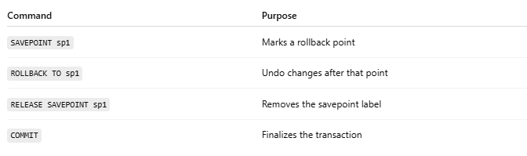
Command | Purpose
SAVEPOINT sp1 | Marks a rollback point
ROLLBACK TO sp1 | Undo changes after that point
RELEASE SAVEPOINT sp1 | Removes the savepoint label
COMMIT | Finalizes the transaction

🧪 Practice Task
# Source: AI Source: Provided by: [Data Path: Persons Table -> ID Column: 1, Name_En Column: Motasem Essam] -> From: [ChatGPT] on [6/11/2026]
Try this:
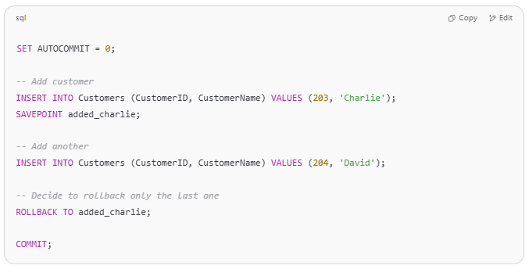
SET AUTOCOMMIT = 0;

-- Add customer
INSERT INTO Customers (CustomerID, CustomerName) VALUES (203, 'Charlie');
SAVEPOINT added_charlie;

-- Add another
INSERT INTO Customers (CustomerID, CustomerName) VALUES (204, 'David');

-- Decide to rollback only the last one
ROLLBACK TO added_charlie;

COMMIT;

✅ Final result: Only Charlie is added.

Example

prepared commands
# Source: ScreenShot Source: Provided by: [Persons Table -> ID Column: 1, Name_En Column: Motasem Essam] -> Tool: [Automation Table -> ID Column: 16, Name_En Column: Screen Capture] -> From [Operating System: Wampserver64 -> phpmyadmin] on [6/11/2026]
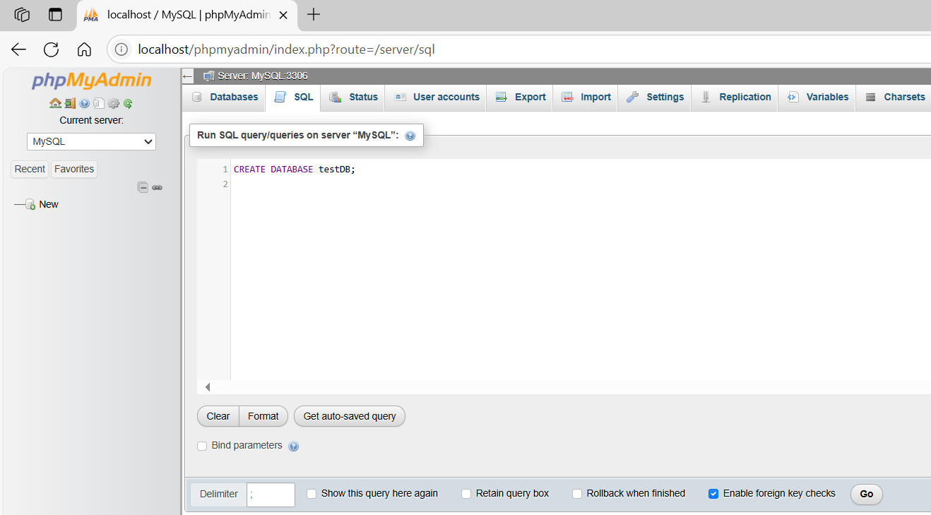
CREATE DATABASE testDB;
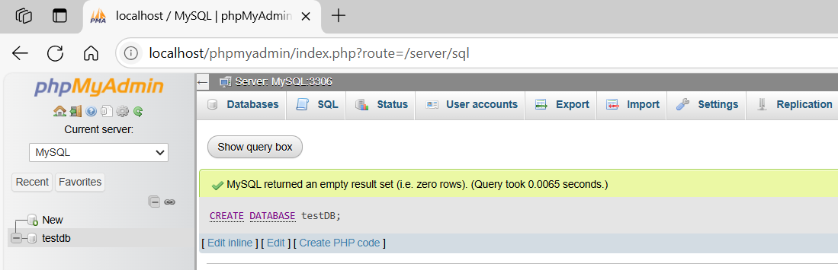
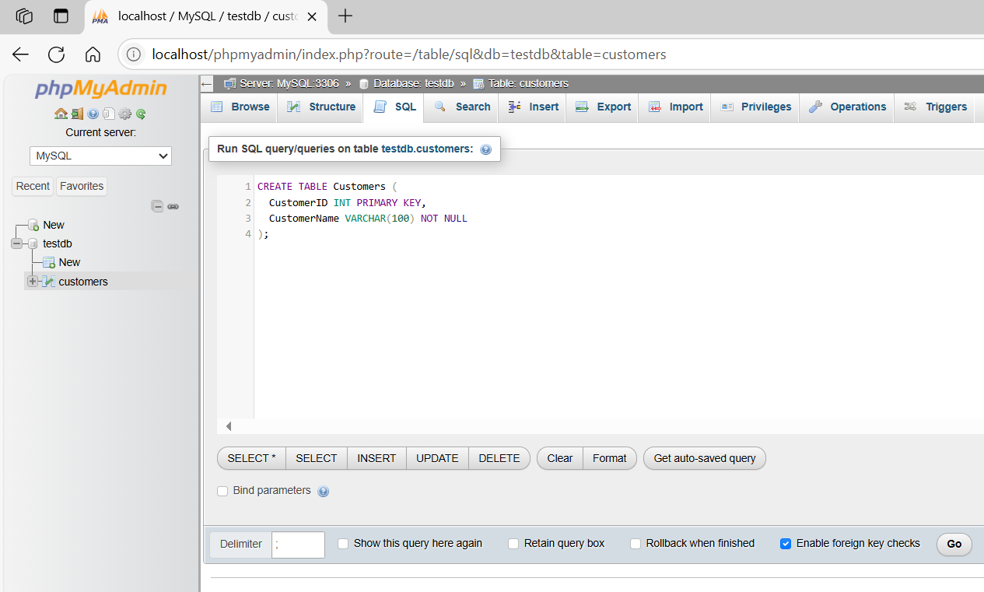
CREATE TABLE Customers (
CustomerID INT PRIMARY KEY,
CustomerName VARCHAR(100) NOT NULL
);
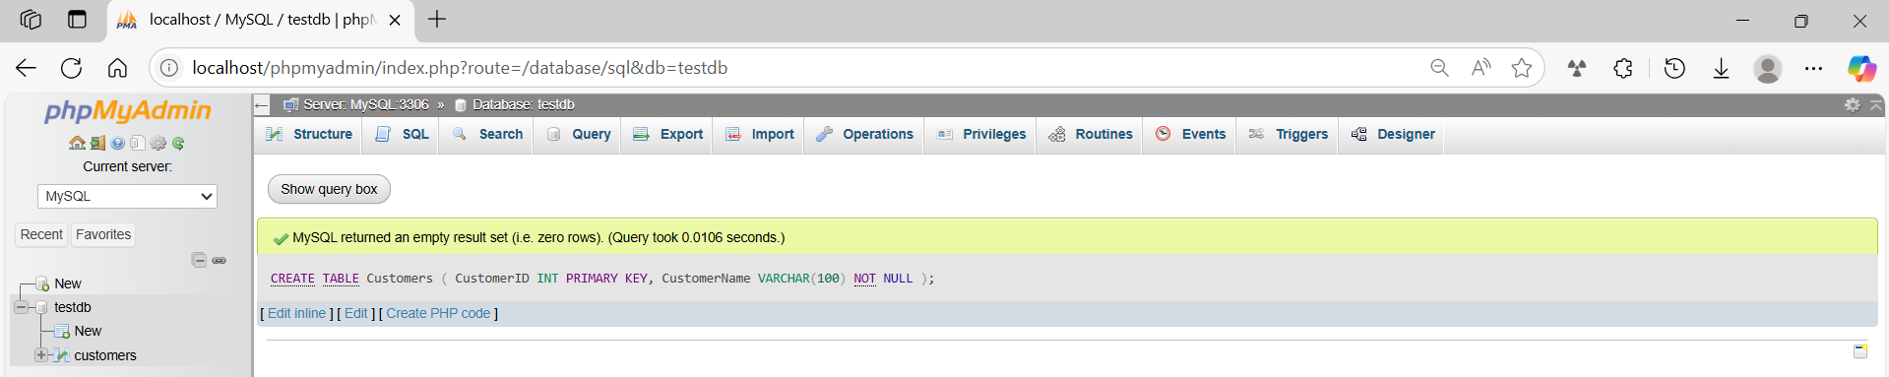

basic command
# Source: ScreenShot Source: Provided by: [Persons Table -> ID Column: 1, Name_En Column: Motasem Essam] -> Tool: [Automation Table -> ID Column: 16, Name_En Column: Screen Capture] -> From [Operating System: Wampserver64 -> phpmyadmin] on [6/11/2026]
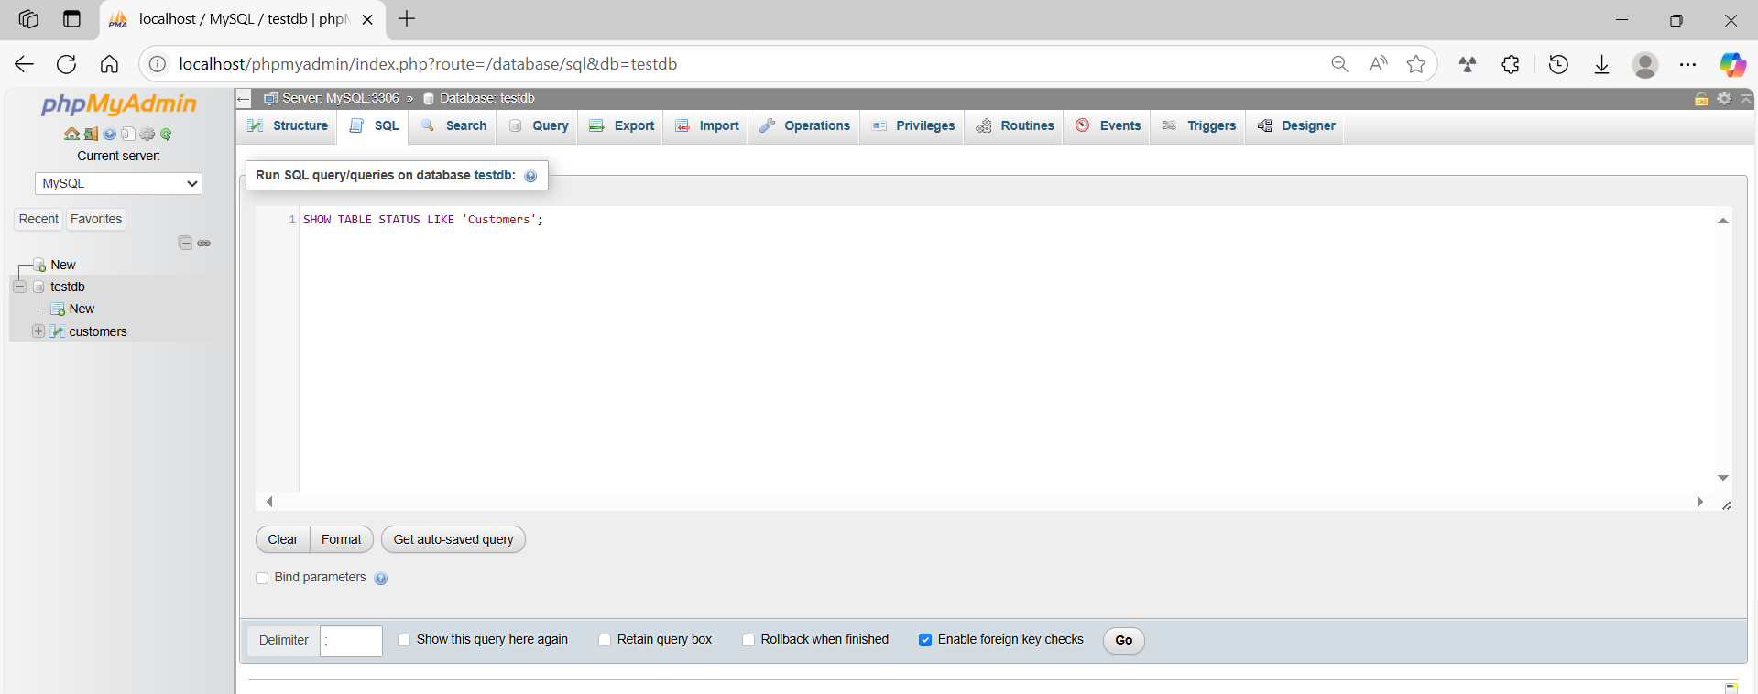
SHOW TABLE STATUS LIKE 'Customers';
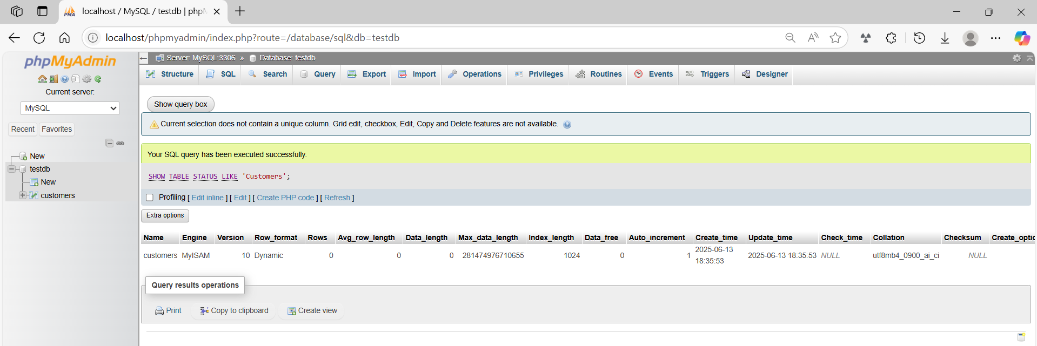
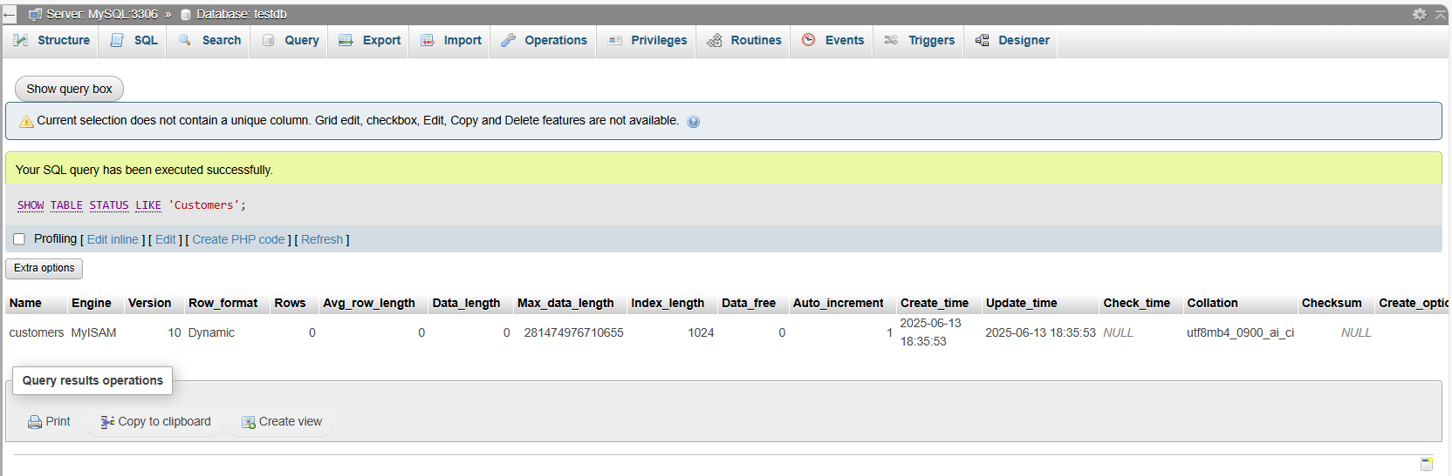

basic command
# Source: ScreenShot Source: Provided by: [Persons Table -> ID Column: 1, Name_En Column: Motasem Essam] -> Tool: [Automation Table -> ID Column: 16, Name_En Column: Screen Capture] -> From [Operating System: Wampserver64 -> phpmyadmin] on [6/11/2026]
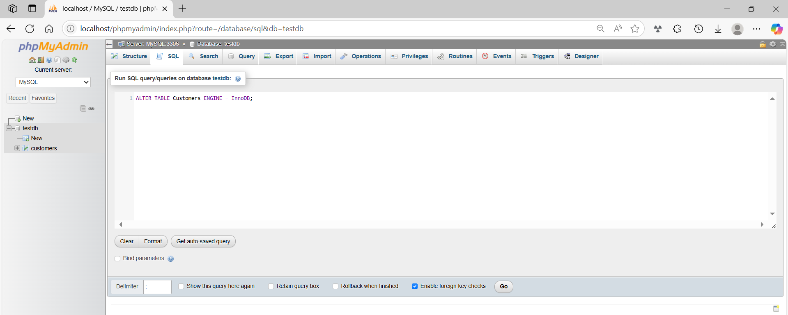ALTER TABLE Customers ENGINE = InnoDB;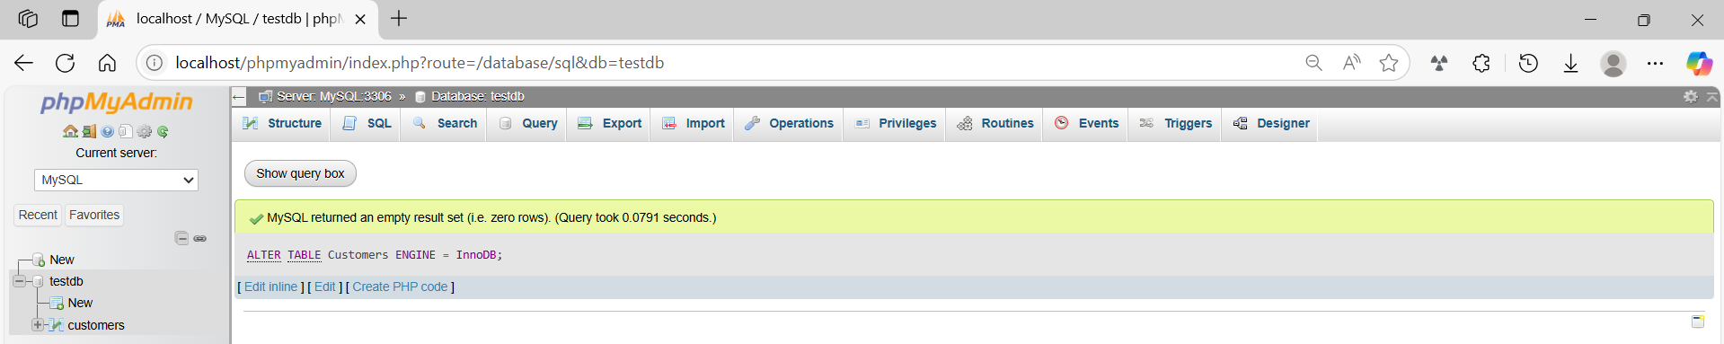

SHOW TABLE STATUS LIKE 'Customers';
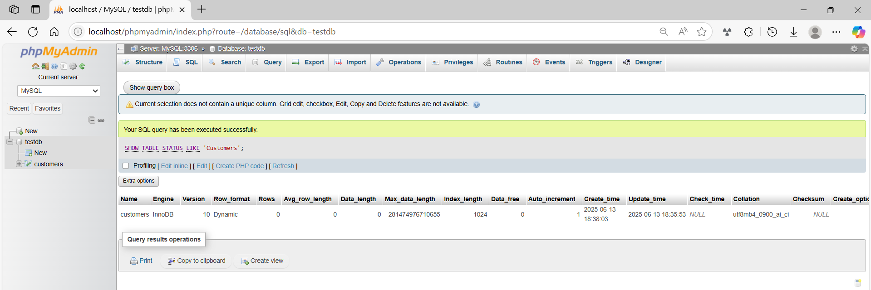
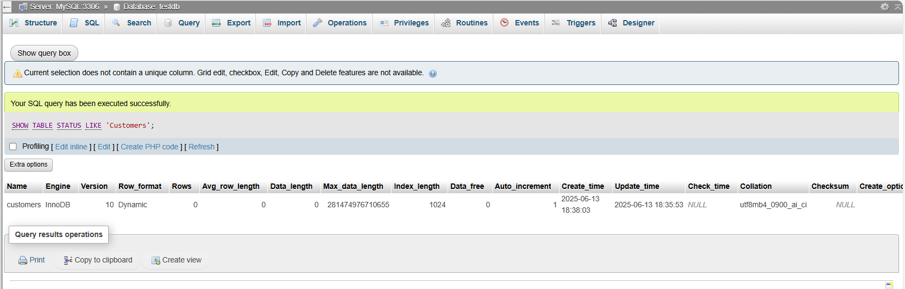

basic command
# Source: ScreenShot Source: Provided by: [Persons Table -> ID Column: 1, Name_En Column: Motasem Essam] -> Tool: [Automation Table -> ID Column: 16, Name_En Column: Screen Capture] -> From [Operating System: Wampserver64 -> phpmyadmin] on [6/11/2026]
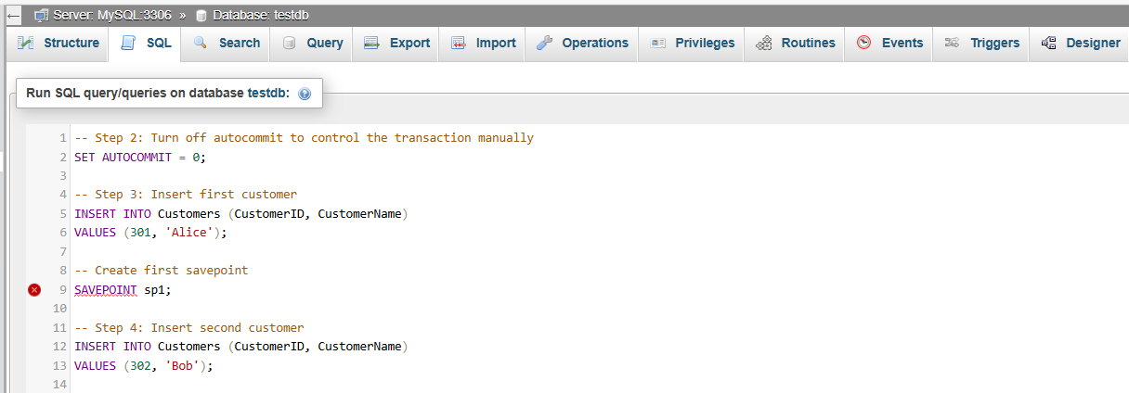
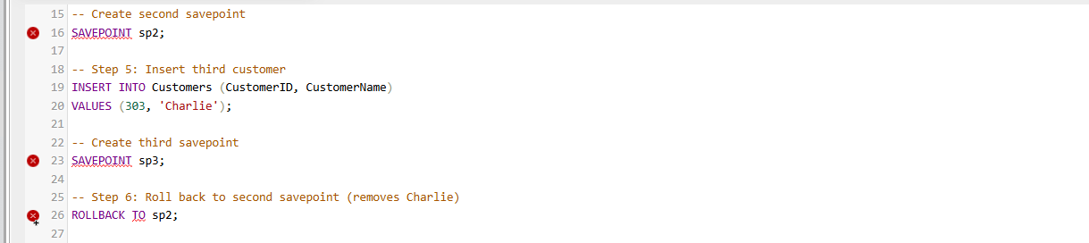
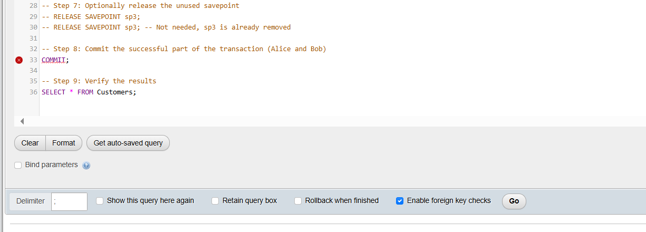
-- Step 2: Turn off autocommit to control the transaction manually
SET AUTOCOMMIT = 0;

-- Step 3: Insert first customer
INSERT INTO Customers (CustomerID, CustomerName)
VALUES (301, 'Alice');

-- Create first savepoint
SAVEPOINT sp1;

-- Step 4: Insert second customer
INSERT INTO Customers (CustomerID, CustomerName)
VALUES (302, 'Bob');

-- Create second savepoint
SAVEPOINT sp2;

-- Step 5: Insert third customer
INSERT INTO Customers (CustomerID, CustomerName)
VALUES (303, 'Charlie');

-- Create third savepoint
SAVEPOINT sp3;

-- Step 6: Roll back to second savepoint (removes Charlie)
ROLLBACK TO sp2;

-- Step 7: Optionally release the unused savepoint
-- RELEASE SAVEPOINT sp3;
-- RELEASE SAVEPOINT sp3; -- Not needed, sp3 is already removed

-- Step 8: Commit the successful part of the transaction (Alice and Bob)
COMMIT;

-- Step 9: Verify the results
SELECT * FROM Customers;

